# ISE 754

## Exam 1

### Pavel “Pasha” Koprov

#### Problem 1.

1. To define the number of reuse facilities and their locations this problem needs to be expressed as the MILP CFL problem. This resulted in 7 facilities with locations in Carrboro, Hillsborough, Efland, and Chapel Hill.

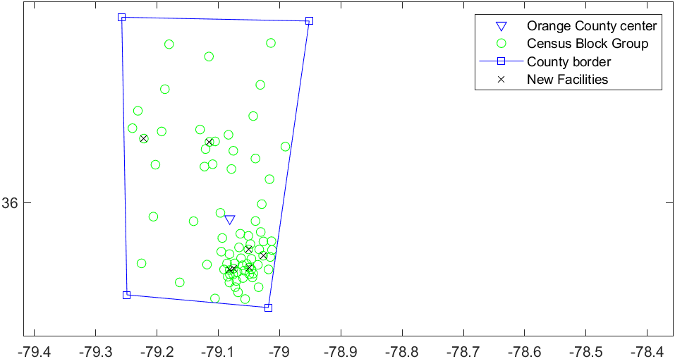

1. The fixed cost was selected to be 100 as a further increase in cost results only in longer calculation time.
2. I have defined all the locations from the US Census Block Group that are located in Orange county by defining the Orange County SCfips from the county dataset. The demand was defined as 4 pounds per-capita for each USCBG. Distances were calculated concerning the area adjustment. The transportation cost matrix was defined as the product of demand and adjusted distances. The fixed cost was selected to be 50. The MILP was formulated as is HW5 Q5 with 2 constraints: Vyi ≥ ΣDemj*xij and Σxij =1, where V = 80000 and Dem is a demand vector. Gurobi solver was used to finding the optimal number and location of the facilities.

#### Problem 2.

1. To find the optimal shipping cost and parameters I have used the MinTLC function to separate and aggregate shipments. The optimal way of shipping was the aggregate TL with a shipping size of 8.46 tons with an interval of 127 days.

sh: TLC TC IC q days isLTL

---------:----------------------------------------------------------------------------------------

1: 6,004.75 3,002.37 3,002.37 5.95 377.00 0

2: 2,165.62 1,115.62 1,050.00 25.00 1,014.58 0

3: 6,632.99 6,490.91 142.08 4.58 174.38 0

Sum: 14,803.36 10,608.91 4,194.46

Aggregate: 9,783.87 8,925.00 858.87 8.46 126.82 0

1. PPiTL and PPiLTL were achieved from the website of the Bureau of Labor Statistics for January 2020. The obsolescence rate for product 1 is 90% which yields 101% of the inventory carrying rate for this product.
2. The data was formed into shipment structure:

sh: f s d v h a

--:-------------------------------------------------------

1: 5.76 8.00 1,167.51 500 1.01 1

2: 9.00 25.00 1,167.51 200 0.21 1

3: 9.60 3.33 1,167.51 100 0.31 1

The approach of finding the optimal transportation method was used from the HW6 Q3 and Q6.